To create ‘vim sample.txt’ –
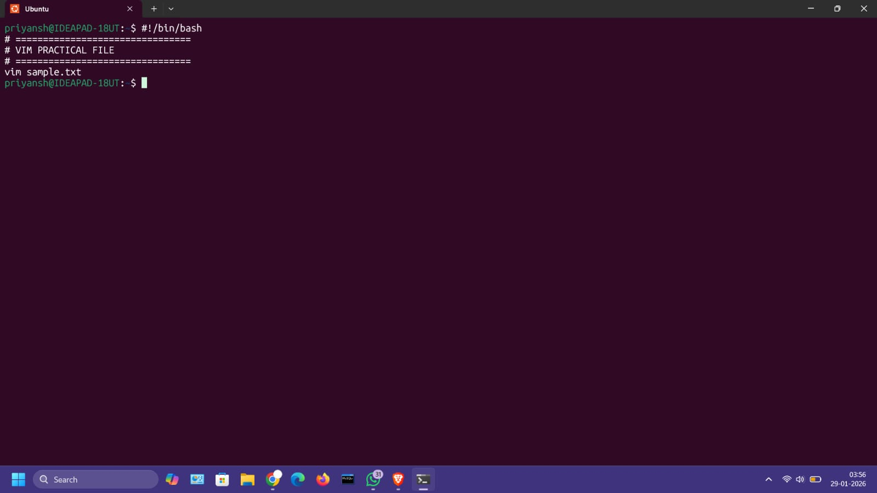
VIM File Script – use esc key for command mode when complete
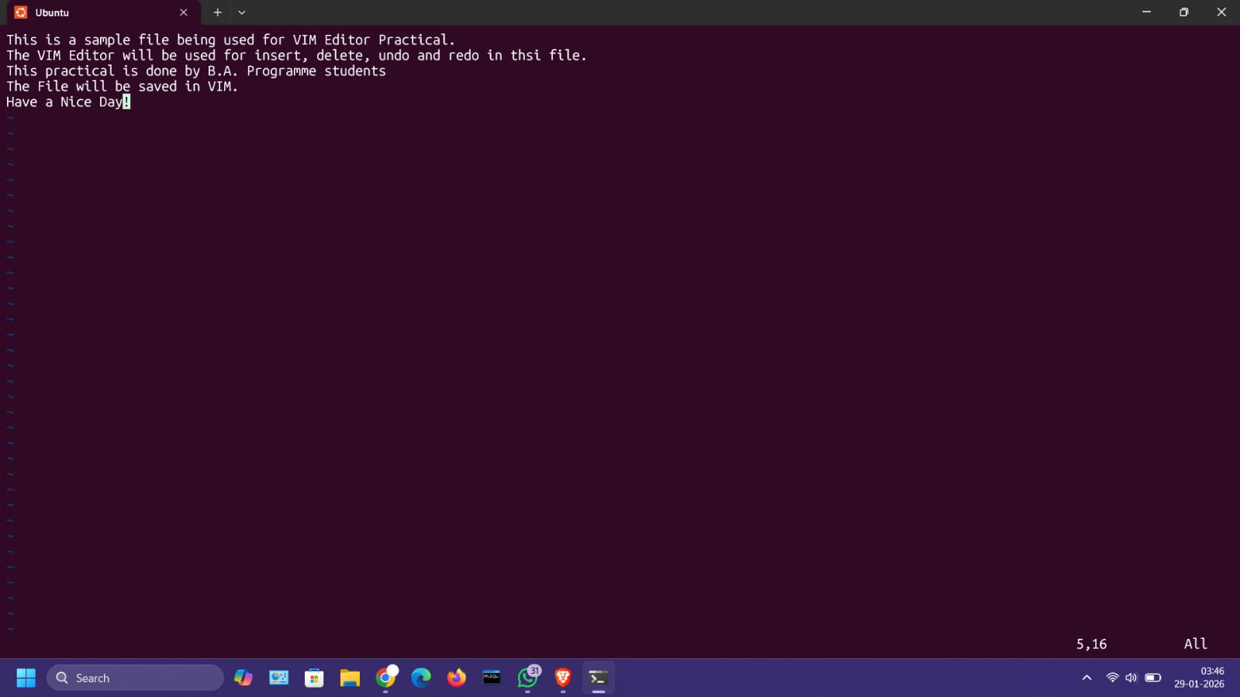
u – for undo
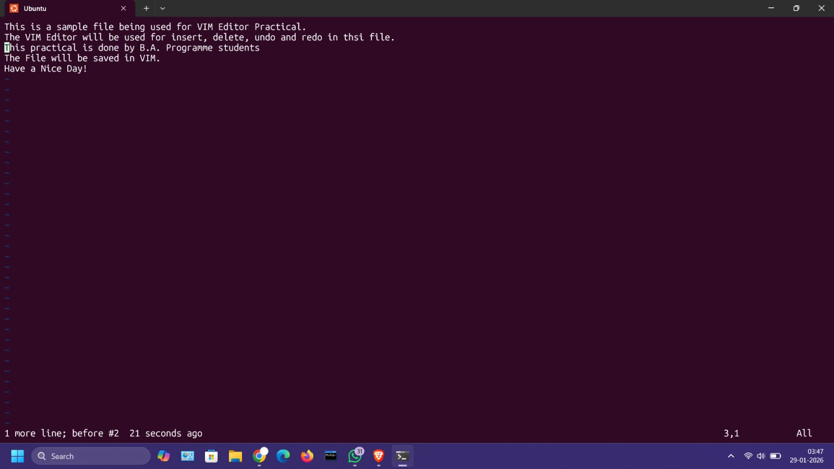
dd – delete
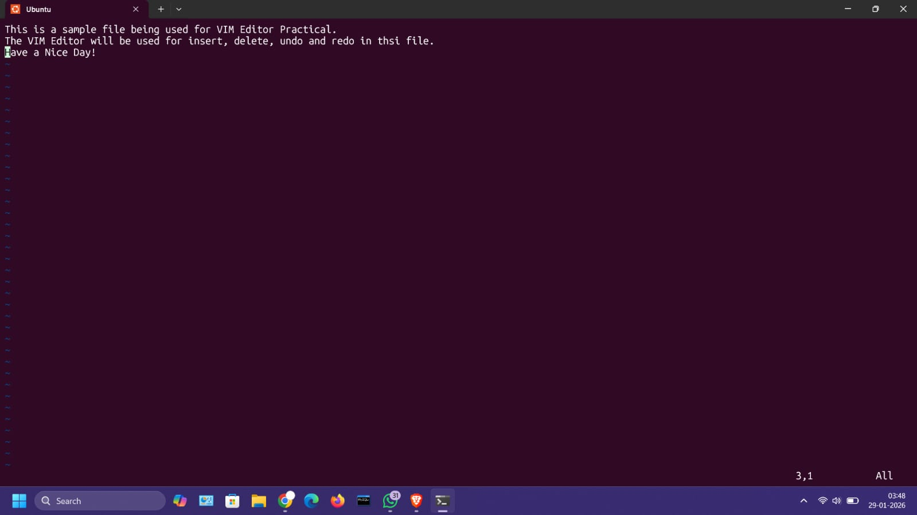
Ctrl + r – redo
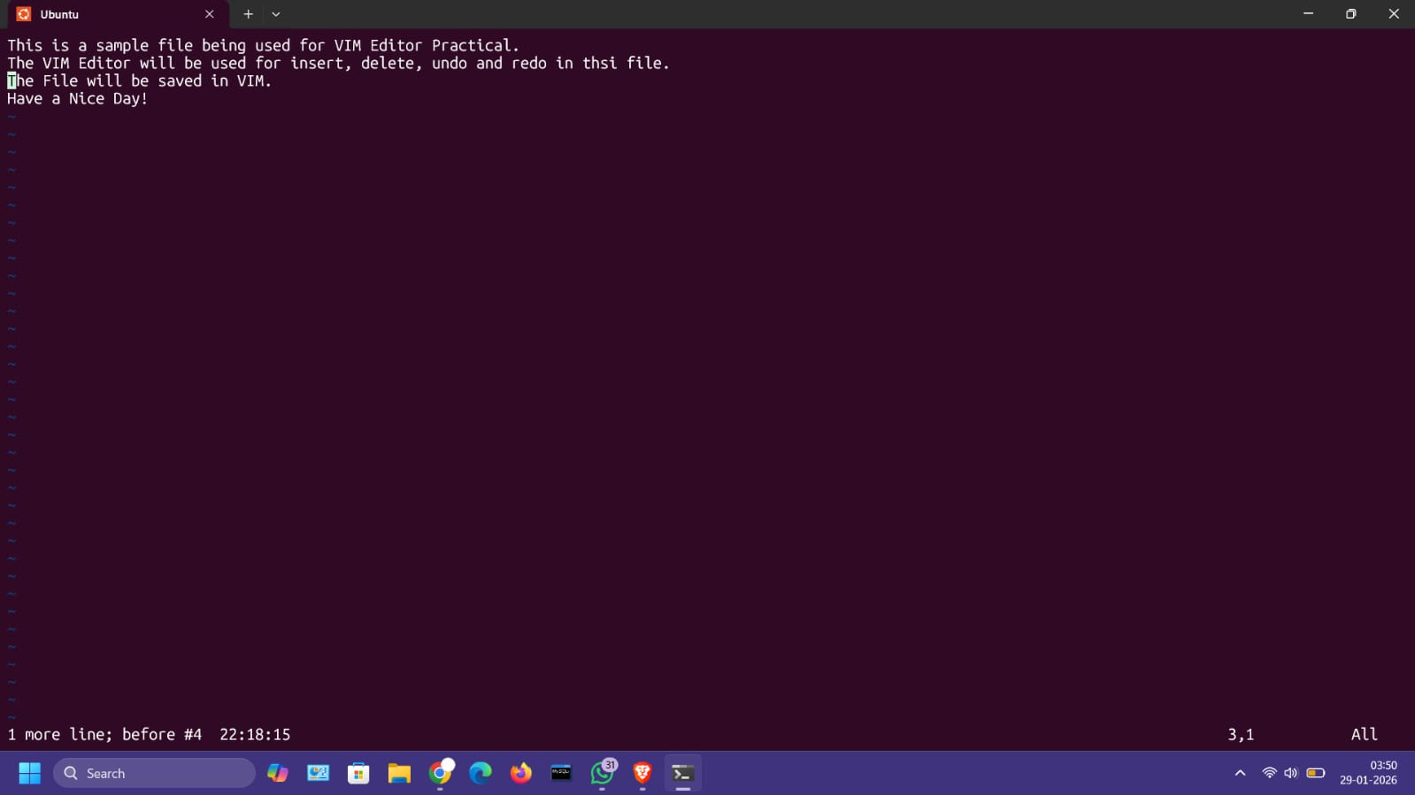
/VIM – to search keyword “VIM” in file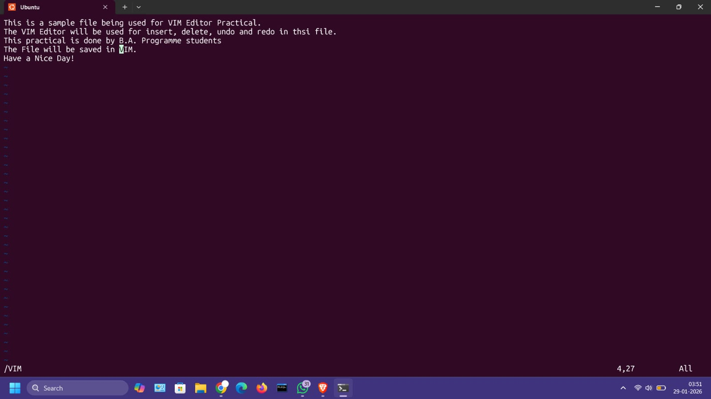
Use ‘n’ for navigation in keyword search results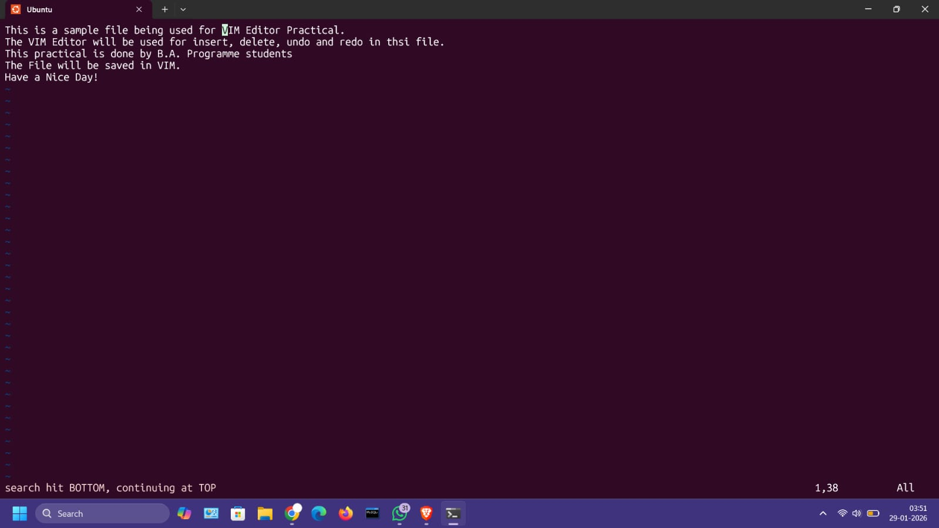
:%s/VIM/VI Editor/g – For replacing the word “VIM” with “VI Editor”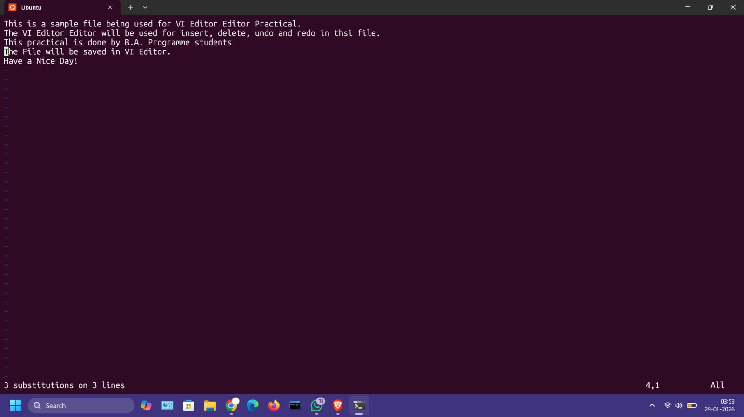
:w – save file
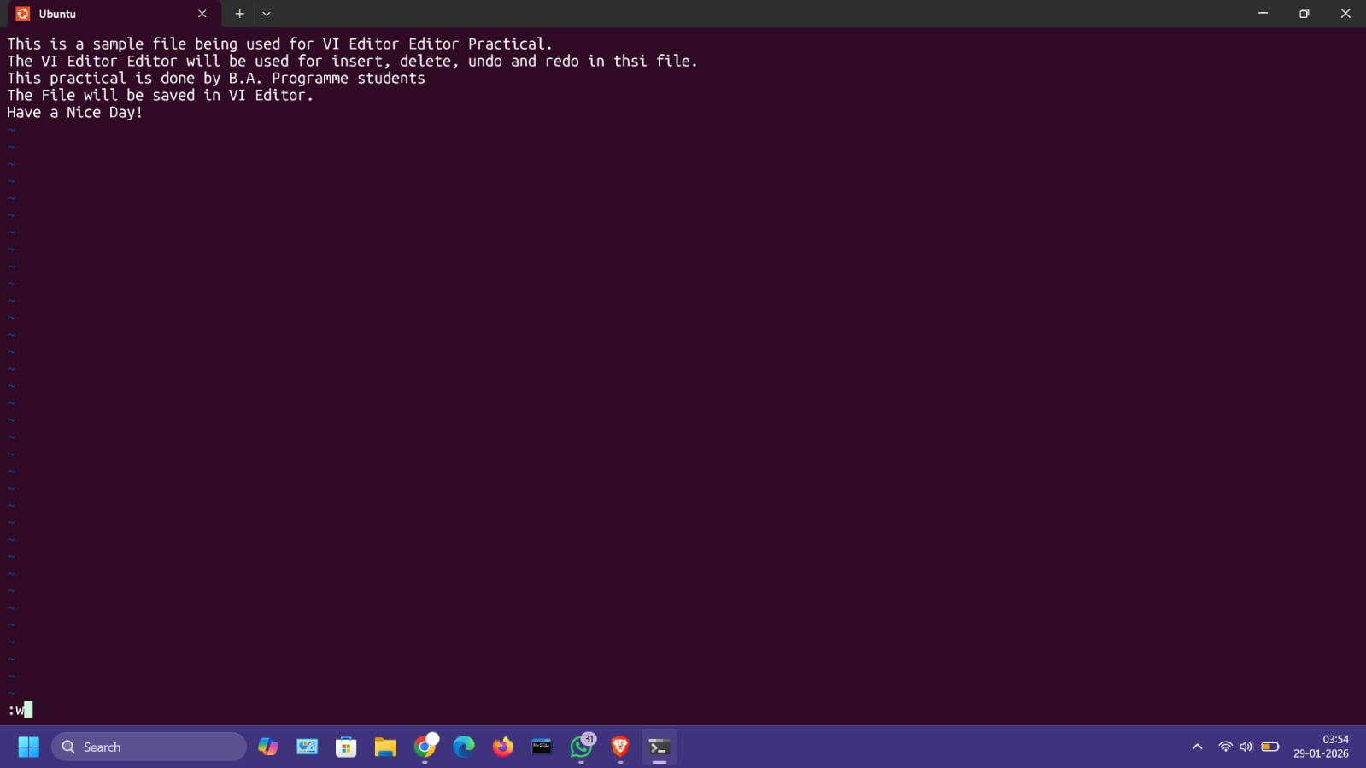
:q – quit the VIM Editor Mode
